FizzBuzz Using OOP (Python)

Python.file:

Screenshot:

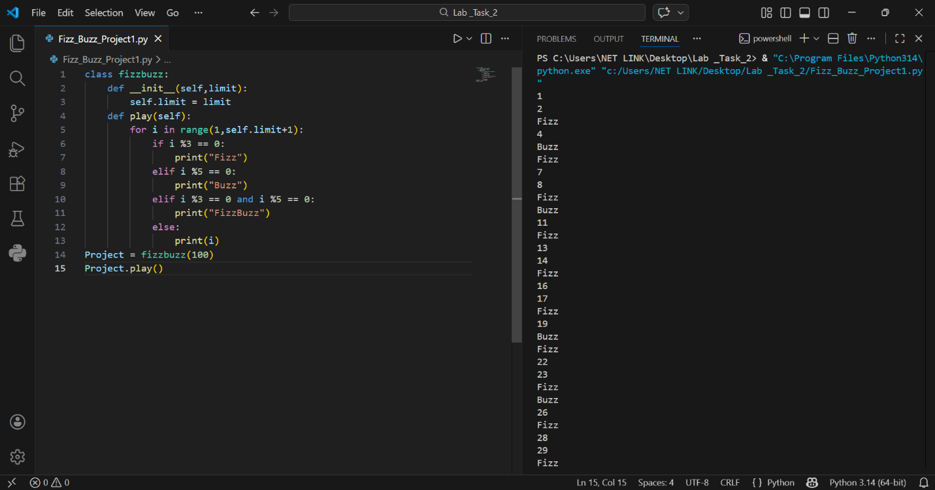

Details
This Python program is a simple FizzBuzz system using Object-Oriented Programming (OOP).
It prints numbers from 1 to 100 with special replacement rules.
Instead of printing some numbers normally:
- If a number is divisible by 3 → Fizz
- If a number is divisible by 5 → Buzz
- If divisible by both 3 and 5 → FizzBuzz
The program runs in the terminal.

Main Components
- Class: FizzBuzz
- Attribute: slef.limt(stores ending number)
- Method: play() to run the program
- Loop: Generates numbers from 1 to 100
- Conditions: Apply FizzBuzz logic

How the Program Works

1. Start
- The program creates an object of the FizzBuzz class.
- A limit value (100) is passed to the constructor.
- This value is stored in self.limt.

2. Loop Execution
- A loop runs from 1 to the given limit.
- Each number is checked one by one.

3. Fizz Condition
- If a number is divisible by 3 → prints Fizz.
- Checked using the modulo operator %.

4. Buzz Condition
- If a number is divisible by 5 → prints Buzz.

5. FizzBuzz Condition
- If a number is divisible by both 3 and 5 → prints FizzBuzz.

6. Normal Number
- If none of the above conditions match → the number is printed normally.

Output
The program prints the FizzBuzz sequence from 1 to 100 in the terminal.
Example Output (First 15 Values):
1
2
Fizz
4
Buzz
Fizz
7
8
Fizz
Buzz
11
Fizz
13
14
Fizz Buzz

